Left Blank Intentionally

We implemented the L3 cache on simplescalar. The code of sim-cache.c was modified to implement the L3 cache, taking inspiration for the pre-written code for L1 and L2 cache. To see the effectiveness of the L3 cache, we downloaded the SPEC benchmarks and ran them against the “sim-cache” simulator, and recorded the performances (based totally on hit rates and miss rates) , for various configurations of L1, L2 and L3 caches.
The name for the benchmark programs were :
1. anagram.ss
2. cc1.ss
3. compress95.ss
4. go.ss
For changing the configuration files l3.cfg was modified. The format of cache details were as follows:

<name>:<nsets>:<bsize>:<assoc>:<repl>
<name> - name of the cache being defined
<nsets> - number of sets in the cache
<bsize> - block size of the cache
<assoc> - associativity of the cache
<repl> - block replacement strategy, 'l'=LRU

Hence the different configuration of L1 , L2 and L3 were chosen as follows :

1. L1: 64:64:1:L
L2: 128:64:1:L
L3: 256:128:2:L

2. L1: 32:32:1:L
L2: 64:32:1:L
L3: 128:64:2:L

3. L1: 128:64:1:L
L2: 256:128:1:L
L3: 512:128:2:L

4. L1: 64:8:1:L
L2: 128:32:1:L
L3: 128:64:2:L

5. L1: 256:128:2:L
L2: 256:256:2:L
L3: 1024:512:8:L

The best performance was (as expected) in the fifth case, since the size of L1 is the largest, hence the hit rates are very significant here.
The files are given attached with the report which holds the values, name of the files are as follows :
<benchmark name>_i.trace where 0<i<5, i represents the cache configuration.

We tried to computationally analyse the changes in programs, which makes a difference in hit rates and miss rates. For that we wrote our own benchmark program comparing two different styles of initializing and accessing arrays.

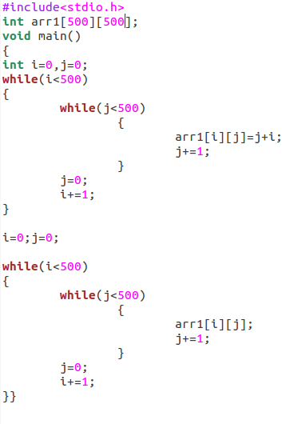

ij.c

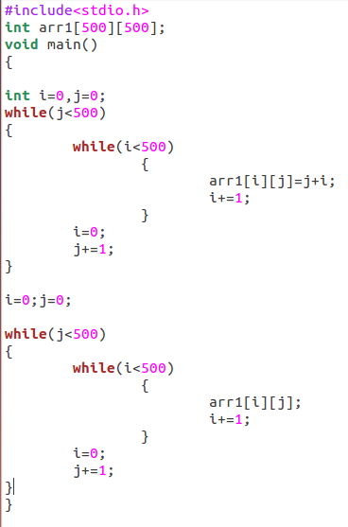

ji.c

For both the programs we tried to analyze the hit rates in data cache of l1.

Initially we run the simple code of just declaring the int array of size int[500][500] and int[5000][5000] , and found both had same number of hit rates in the dl1 cache and concluded that it must be the junk value provided by simplescalar.

-cache:dl1 dl1:256:32:1:l

The number of accesses in dl1 cache are the same for both program but hit rate is significantly different.

For the ij.c program the number of hits in dl1 are 2725022 out of 2758799
and for ji.c program the number of hits in dl1 are 2511857 out of 2758799

and the reason for that was assumed to be that the way matrices are stored and accessed in the computer. For ij the accessing order was sequential unlike for ji, hence desired value was not stored in the cache.

So for cross checking, we increased the size of cache to a higher value and increased the associativity of the cache as well, so that there are no conflicts that happen due to direct mapping and also such that the whole data could be accommodated in the cache.

So we increased the size of cache to a larger value dl1:64:2048:8:l , and the results were amazing as expected.

The number of access were same as usual
The number of hits in dl1 cache in case of ij.c was 2757803 out of 2758799
and for ji.c it was 2758300 out of 2758799, which is only slightly lesser than that of ij.c.

The actual output of sim-cache.c is accompanied in the tar file, for reference, termed as ij_1.out, ij_2.out, ji_1.out and ji_2.out (<filename>_i.out , where i=1 represents with first configuration and i=2 represents second configuration) .

We also searched for potential programs which does the same thing, just implemented the different way can make a difference. For example

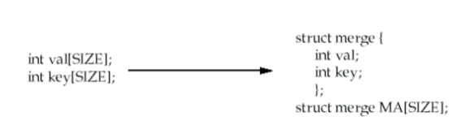

This brings together corresponding elements in both arrays, which are likely to be referenced together. Reorganizing and fetching them at the same time can reduce misses. This technique reduces misses by improving spatial locality. In large cases it can significantly affect the output, hence it's interesting to know and reason based on the open source tool simplescalar.

The files changed were sim-cache.c to sim-sid.c accordingly Makefile was also changed. l3.cfg was made to change the configurations of the cache.

